This document is merely to point out the differences in confessional count numbers between my findings and the official numbers posted on Survivor Sucks. The guidelines I use can be found [here](https://docs.google.com/document/d/18ofsPiVWxSejzSjEGlU8KEx4Og2ddEJScCV23RsCPIA/edit?usp=sharing).

**Survivor Sucks Season 07 Counts** ([link](https://goo.gl/photos/sZ81yZwbn9JNpRwK7))

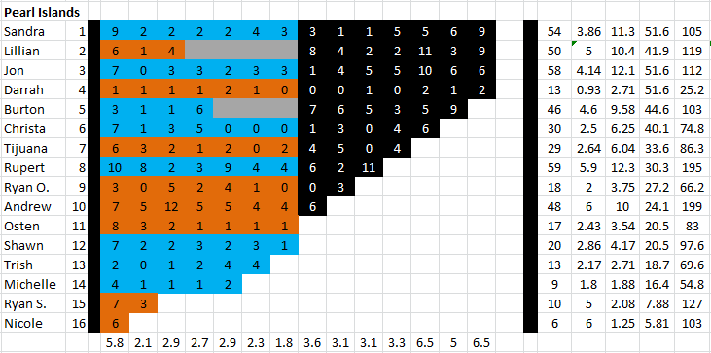

**My Season 07 Counts** ([link](https://goo.gl/photos/pjPFcBJHpbqV1SPo6))

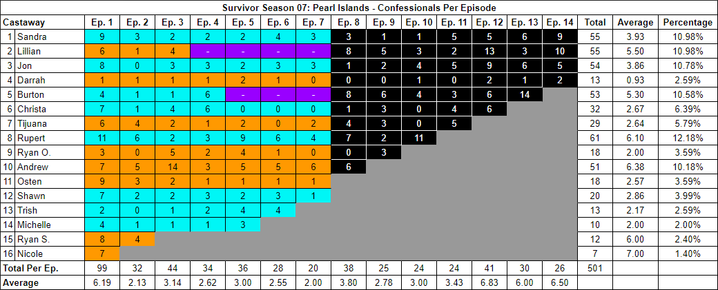

[Survivor Sucks Season 07 thread](http://survivorsucks.yuku.com/topic/4311).

**Differences**

[Episode 01](https://docs.google.com/document/d/11BaKzzykZB7SG3L4ptPyy9XDuxU-Nxt0dLvT_XAFWHc/edit?usp=sharing)

* **Jon 8 (+1)** Confessional #46 is a voice over which also has a 10s gap.
* **Burton 4 (+1)** Confessional #77 has an 11s gap.
* **Rupert 11 (+1)** I got a total of 11 confessionals for Rupert instead of the established 10. No significant gaps.
* **Osten 9 (+1)** Confessional #14 has a 10s gap.
* **Ryan S. 8 (+1)** Confessional #31 has a 13s gap.
* **Nicole 7 (+1)** I got a total of 7 confessionals for Nicole instead of the established 6. No significant gaps.
* **Note:** Confessional #74 is an on-the-fly confessional where Andrew talks to the camera as his tribemates work on the background. Chyron present.

[Episode 02](https://docs.google.com/document/d/18RLuLT6tiSOIv4w4UKurlFi4wxDgc675RW3zkWLtRGo/edit?usp=sharing)

* **Sandra 3 (+1)** Confessional #14 is a voice over, plus it has an 11s gap.
* **Tijuana 4 (+1)** I got a total of 4 confessionals for Tijuana instead of the established 3. No significant gaps.
* **Rupert 6 (-2)** I got a total of 6 confessionals for Rupert instead of the established 8. No significant gaps.
* **Ryan S. 4 (+1)** Confessional #9 has a 13s gap.

[Episode 03](https://docs.google.com/document/d/1Z-dRuH2aU3B_OEKpAr9EVc8m_IicMQUVJpRQmN4TbD4/edit?usp=sharing)

* **Christa 4 (+1)** Confessional #32 has a 13s gap.
* **Andrew 14 (+2)** Confessional #41 has an 11s gap.

[Episode 04](https://docs.google.com/document/d/1YvWoImb3izPyXMBe7lrrVp4ygLikb2gumn57Z94Taco/edit?usp=sharing)

* **Christa 6 (+1)** I got a total of 6 confessionals for Christa instead of the established 5. No significant gaps.
* **Andrew 3 (-2)** I got a total of 3 confessionals for Andrew instead of the established 5. No significant gaps. **Note:** Confessional #2 is an on-the-fly confessional, because towards the end of it, you can see someone walking right behind Andrew (chyron present).

[Episode 05](https://docs.google.com/document/d/1mHjZzCC01avhVLVoMV7e8zxFxbvWBAa6PCTl35IhKEQ/edit?usp=sharing)

* **Michelle 3 (+1)** Confessional #30 has a 13s gap.

[Episode 06](https://docs.google.com/document/d/1PHSlY75Zwn-XEHX7Z70dbw7Tw51e5jU3tjuMHp8-_6U/edit?usp=sharing)

* **Rupert 6 (+2)** Confessional #2 has a 15s gap.
* **Andrew 5 (+1)** Confessional #18 has a 14s gap.

[Episode 07](https://docs.google.com/document/d/1ZgPpwP3WjMtL8-ZiOr-KXQqNFyPlX8wKeKxWOUqFLQM/edit?usp=sharing)

* **Andrew 6 (+2)** Confessional #6 has an 11s gap.

[Episode 08](https://docs.google.com/document/d/11czcsdsM9l3W05sxxQ0xqLX_UeeLynvjbR373Zg_Q14/edit?usp=sharing)

* **Burton 8 (+1)** I got a total of 8 confessionals for Burton instead of the established 7. No significant gaps.
* **Rupert 7 (+1)** Confessional #11 has a 12s gap.

[Episode 09](https://docs.google.com/document/d/1bV5rdPiMTzNmB0GSWyD6ltYhg5Z-a1u6fpHFURVTqBs/edit?usp=sharing)

* **Lillian 5 (+1)** Confessional #14 has a 10s gap.
* **Jon 2 (-2)** I got a total of 2 confessionals for Jon instead of the established 4. No significant gaps.
* **Tijuana 3 (-2)** I got a total of 3 confessionals for Tijuana instead of the established 5. No significant gaps.

[Episode 10](https://docs.google.com/document/d/1iO5aCJ8P7x58TNzEysV6kBFMgtifbP1Kx-JzqTTrxGQ/edit?usp=sharing)

* **Lillian 3 (+1)** Confessional #15 has a 12s gap.
* **Jon 4 (-1)** I got a total of 4 confessionals for Jon instead of the established 5. No significant gaps.
* **Burton 4 (-1)** I got a total of 4 confessionals for Burton instead of the established 5. No significant gaps.

[Episode 11](https://docs.google.com/document/d/1Z0_06OkrpnLCzT_0iun6ZXtHYSdIhwRr7YKrJ1F4XN4/edit?usp=sharing)

* **Tijuana 5 (+1)** Confessional #22 is an on-the-fly confessional in which Tijuana walks on the beach alongside Darrah and she narrates to the camera. No chyron present.

[Episode 12](https://docs.google.com/document/d/1M-5D4hYphP7dU30B8PciNKjkwNyfRj0Y9HYD7GvpCrk/edit?usp=sharing)

* **Lillian 13 (+2)** Confessional #6 has an 11s gap, and confessional #7 is a voice over.
* **Jon 9 (-1)** Confessional #20 has a 9s gap.
* **Burton 6 (+1)** I got a total of 6 confessionals for Burton instead of the established 5. No significant gaps.

[Episode 13](https://docs.google.com/document/d/1HoduT_nCfEzALymY3hfHuf_n5jFfdK_0MQrmI4oNNyY/edit?usp=sharing)

* **Burton 14 (+5)** Confessional #7 has a 14s gap, and confessional #11 has a 12s gap.

[Episode 14](https://docs.google.com/document/d/160Pr3e6DpW4NbqsoOOqHPb7DvoFIX-1I6__G5IH_AWQ/edit?usp=sharing)

* **Lillian 10 (+1)** Confessional #6 has a 13s gap, and confessional #7 is a voice over.
* **Jon 5 (-1)** I got a total of 5 confessionals for Jon instead of the established 6. No significant gaps, instead of a 14s gap (#4) which doesn’t affect anything.

|  |  |  |
| --- | --- | --- |
| **Castaway** | **Count** | **Change** |
| Sandra | 55 | +1 |
| Lillian | 55 | +5 |
| Jon | 54 | -4 |
| Burton | 53 | +7 |
| Christa | 32 | +2 |
| Rupert | 61 | +2 |
| Andrew | 51 | +3 |
| Osten | 18 | +1 |
| Michelle | 10 | +1 |
| Ryan S. | 12 | +2 |
| Nicole | 7 | +1 |
| **Total** | **501** | **+21** |

**Revised Sucks Counts** (link)